# Safety Warnings

THE MICRO:BIT IS AN EXPOSED BOARD, TO BE USED WITH CARE PLEASE RETAIN THIS INFORMATION FOR FUTURE REFERENCE. You can read the detailed document at - <http://microbit.org/guide/safety-advice/>

# General Safety Warnings

Using the BBC micro:bit is easy to use but is designed to have all the electrical parts on display. This does mean there's a small risk that the parts can be damaged and even overheat with a risk of injury but a little bit of care and caution will ensure you and your micro:bit will stay fit and healthy.



1. Always keep your BBC micro:bit in the anti-static bag when not in use. It's good practice for students to earth themselves before handling it.
2. Please handle your BBC micro:bit by its edges. This minimises the risk of damage through an electrostatic discharge.
3. Please use the battery pack and the USB lead provided to power your micro:bit. Do not use portable battery chargers or USB charging ports (often marked with a lightning bolt or 'SS'), to power your micro:bit. Using these may damage your micro:bit and stop it working properly.
4. Please avoid handling the BBC micro:bit circuit board while plugged into a power supply.
5. All peripherals (for example: USB cable, battery holder, sensors) used with your BBC micro:bit should comply with the relevant standards and should be marked accordingly.
6. Connecting your BBC micro:bit to any unapproved peripherals could damage your BBC micro:bit
7. Please do not attempt to keep using faulty micro:bits. If a school-issued micro:bit develops a fault, contact the vendor immediately.
8. The maximum current safely supplied to an external circuit using the 3V pin on the edge connector is 100mA. Please make sure this limit is not exceeded.
9. Please do not store or use your BBC micro:bit in extremely hot or cold environments.
10. Do not place any metal objects across the printed circuits on the board as this can cause a short circuit damaging your BBC micro:bit. This can cause risk of burn or fire.
11. Do not use your BBC micro:bit in water or with wet hands.
12. Do not leave your BBC micro:bit plugged into a computer or any other device unsupervised.
13. Please do not leave your BBC micro:bit within reach of children under 8 years of age.
14. Please operate your BBC micro:bit in a well ventilated room To remove the battery pack, pinch the connector with your fingers. Do not remove by pulling the wires.

# Battery Warnings



1. Do not try to charge normal (non-rechargeable) batteries
2. Please do not mix different types of batteries or mix new and used batteries.
3. Please use batteries of the same or equivalent type as those recommended.
4. Please insert batteries the correct way round (with the correct polarity).
5. Please remove spent batteries from the battery holder.
6. Do not short-circuit the battery supply terminals, for example by placing a metal object across the terminals.
7. Only use Zinc or Alkaline batteries with your BBC micro:bit.
8. Please do not use rechargeable batteries

# Pre-requisites

If you need assistance with the assembly of the micro:bit, Edge connector breakout board, mounting board and the breadboard please speak to one of the volunteers on duty.

To be able to perform this tutorial you will need the following components –

1. Parts required –
   1. 1 x BBC Micro:bit
   2. 1 x Mounting Plate
   3. 1 x Edge connector breakout board
   4. 1 x Bread board
   5. 2 x LED
   6. 1 x 2.2K (2200) Ohm Resistor
   7. 1 x 47 Ohm Resistor
   8. 3 x Male – Female Dupont wires
   9. 3 x Male – Male Dupont wires
2. Assembly required –
   1. Bread board mounted on top of the mounting plate
   2. BBC Micro:bit inserted into the Edge Connector breakout board

# C:\Perf\Personal\Github\CoderDojo\Images\Hi_Res_BBC_Microbit.jpg

Before proceeding please check your setup and confirm that all the required parts are configured as demonstrated in the above picture.

# Learning Objectives

The objectives of this tutorial are to explore and learn the basic concepts of electricity, circuits, parallel circuits and elements that make up a parallel circuit. This tutorial builds upon concepts introduced in previous tutorials so please make sure you have covered the previous tutorials before you dive into this one.

Explore the following concepts through making –

1. What is a parallel circuit
2. Current flowing through a parallel circuit
3. How does the flow of current in a parallel circuit differ from that in a series circuit
4. What are passive and active components in a parallel circuit
5. Connecting elements in a circuit in parallel
6. How does the voltage drop across the LED’s in a parallel circuit (shown below) differ from the voltage drop across two LEDs connected the series circuit.
7. **How does addition of a second resistor in parallel to the first impact the flow of current through the parallel circuit**

# Activity

Before we get started, let’s make sure that all the required components are configured as required. If you’ve completed tutorial 4b1 you can choose to read up through Step 1a and Step 1b and then just dive into creating the circuits using Step 1c. You are encouraged to re-create Step 1a, Step 1b and then modify the circuit for Step 1c which will help in reinforcing the fundamental laws of electricity.

# Step 1a - Build

Let’s now connect up the relevant components on our micro:bit.

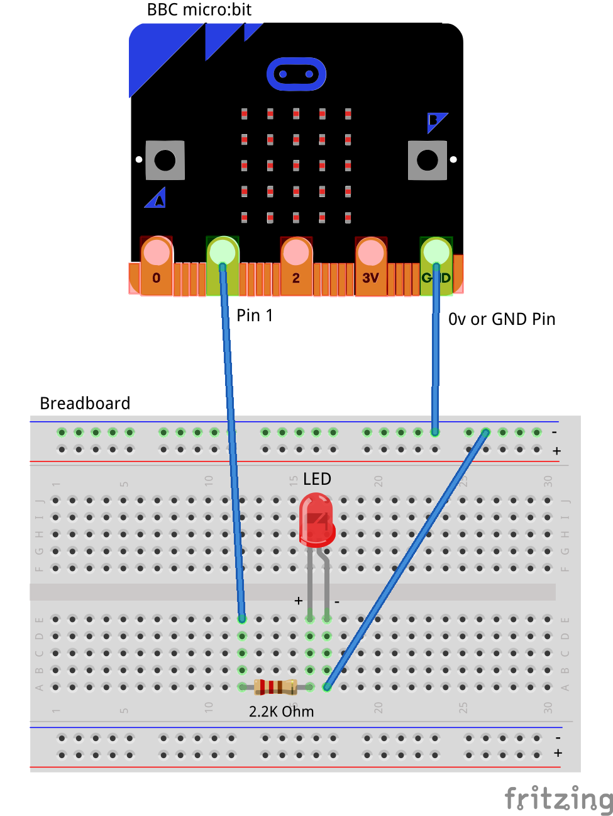

You will realize that the diagram above is similar to the one you have seen in the previous tutorial. The first step in this tutorial involves putting together a series circuit with all the elements i.e. LED, Resistor and micro:bit which you’ve used in the previous tutorial. In the next step we will then extend this circuit to include elements in parallel.

# Step 1b - Build

Let’s now add the new bits to the micro:bit and extend the circuit we’ve built.

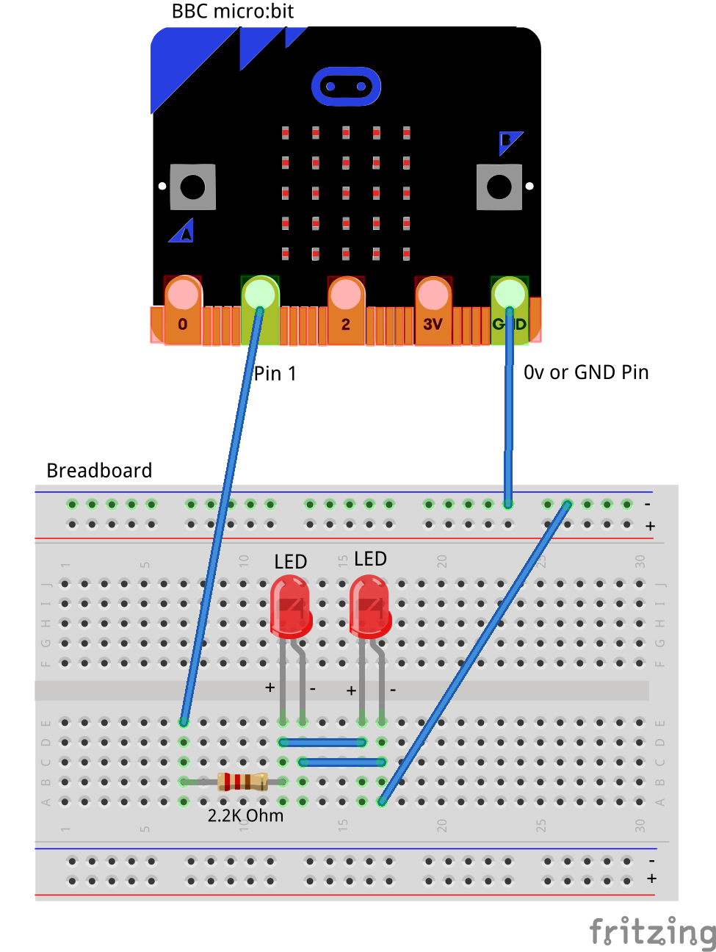

In step 2 you connect up the second LED in parallel to the first LED with a slight modification to the circuit. The main difference between the first circuit and the second is the addition of the second LED in parallel which causes the current to split between both the LED’s equally. The voltage drop however across both the LED’s are now the same because they are in parallel. The total voltage drop across the circuit is the sum of the voltage across the resistor and the LED’s i.e. Vtotal = Vresistor + Vled

However, in our previous tutorial where we build the series circuit which included two LEDs and two Resistors, the voltage drop across the circuit is a combination of, Voltage across LED1 + Voltage across LED2 + Voltage across resistor1 + Voltage across resistor 2. The equation can be written as Vtotal = Vled1 + Vled2 + Vresistor1 + Vresistor2

The connections should be made as follows:

1. Connect the Male – Female Dupoint wire from the Ground (0v) pin to the ground rail on the breadboard.
2. Connect a Male – Female Dupont wire from Pin1 pin on the micro:bit (using the Edge Connector Breakout board) to 2.2K Ohm resistor on the breadboard
3. Connect the 2.2K resistor to the Anode (Positive, Longer leg) of the LED on the breadboard
4. Connect the Anode (Positive, Longer leg) of the first LED to the Anode (Positive, Longer leg) of the second LED.
5. Connect the Cathode (Negative, Shorter Leg) of the first LED to the Cathode (Negative, Shorter Leg) of the second LED.
6. Connect a Male – Male Dupoint wire from the Cathode (Negative, Shorter leg) of the second LED to the ground rail (0v) on the breadboard.

The flow of the current is now from Pin1 to the resistor, splitting into two across the two LEDs and then back to ground. Therefore, the current through each of the LED’s should in theory be half of the current that flows through the resistor. However, the voltage across the LED should be the same for both the LED’s since they are in parallel.

# Step 1c - Build

Let’s now add the new bits to the micro:bit and extend the circuit we’ve built.

There next part of the circuit has a minor change which includes addition of another resistor in parallel with the first resistor both of which are in series with the LED’s. To re-state what we’ve just said – the two LED’s are connected in parallel with each other, the two resistors are also connected in parallel with each other however the two LED’s in parallel are connected in series with the two resistors which are also in parallel with each other.

Take time to read through the above statements and if confused please reach out to the volunteer/mentor for clarification.

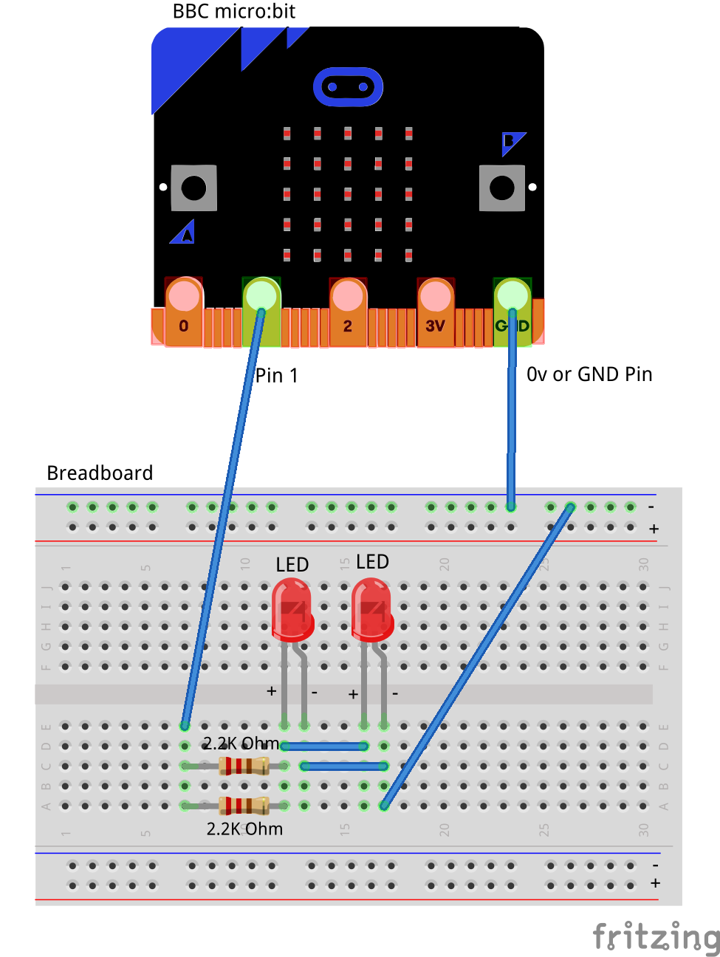

The first resistor we used was a 2.2K (2200) Ohm resistor. If you chose to add a 2.2K Ohm resistor in parallel with the first resistor what do you think should happen? Will the resistance increase or will it decrease? Adding two resistors of the same value in parallel leaves the total resistance un-changed and the current will be equally resisted by both the resistors. However let’s look at the scenario below where we use a lower value resistor i.e. 47 Ohm resistor in parallel with a 2.2K Ohm resistor.

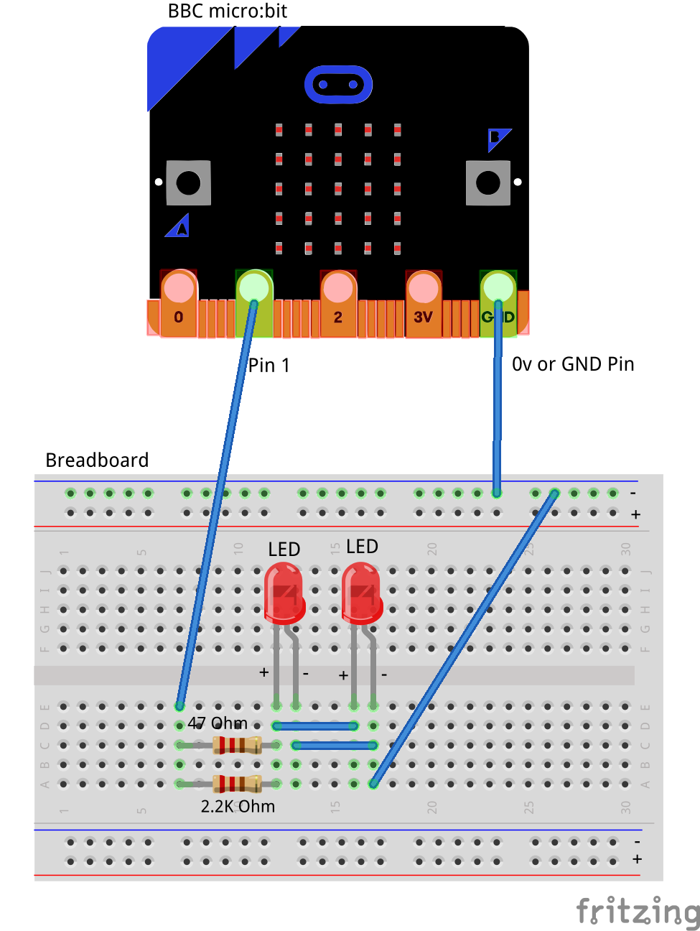

In the above scenario the current senses two different types of resistance one low (47 Ohm) and one high (2.2K Ohm) as a result the current choses to flow through the lower resistance. The behaviour of current in this system is very different from what we’ve seen earlier and quite interesting indeed.

## Self-Assessment

* I have the breadboard mounted onto the mounting plate.
* I have the micro:bit plugged into the Edge connector breakout board.
* I understand each of the components in the circuit i.e. LED, resistor, Male – Female Dupont wires
* I have each of the elements in the circuit wired up using the breadboard
* I have checked the connections on the circuit and have not powered it on.
* I understand the use of the 2.2K resistor in the circuit
* I understand the difference between 3 Volt (3V) and Ground (0 Volt of 0V)
* I understand how to use the male – male and male – female dupont cables to create connections using the breadboard
* I understand what the positive / 3v and ground / 0v rails (top and bottom) of the breadboard do and how they are connected
* I understand how the central rows in the breadboard are lined up together and how they are connected.

This now completes your circuit.

**PLEASE DO NOT POWER ON YOUR micro:bit UNLESS YOU HAVE HAD YOUR CIRCUIT VALIDATED BY A FACILITATOR/MENTOR/Volunteer.**

# Step 2 - Explore

Discuss the following concepts with the learning facilitator

1. What is a series circuit? Which components in this circuit are in series?
2. What is a parallel circuit? Which components in this circuit are in parallel?
3. What are the paths for current flowing through this parallel circuit?
4. Which are passive and active components in a parallel circuit?
5. How does the voltage drop across the LED’s in a parallel circuit (shown below) differ from the voltage drop across two LEDs connected the series circuit.

## Self-Assessment

* I can explain what a circuit means, what are components connected in series and components connected in parallel.
* I can explain the differences between active and passive components in circuits.
* I understand how components can be connected in series.
* I understand how components can be connected in parallel.
* I understand how the current flow changes in parallel circuits as compared to series circuits.
* I understand how the voltage drop across the LED’s in the parallel circuit differs from the voltage drop across the LED’s in the series circuit.
* I understand how the addition of the second LED changes the flow of current through the LEDs in parallel
* I understand how the addition of the second resistor in parallel changes the flow of current through the resistors in parallel

# Step 3 – Validate

Please call a facilitator to check your circuit before you power it on. It is important that you get a learning facilitator/mentor/volunteer to check the connections on your circuit before powering it on.

Incorrect connections might result in a dead (bricked, burnt, short-circuited, etc.) Micro:bit requiring you to purchase another Micro:bit for $30 AUD.

# Step 4 – Power On

Awesome, you are almost at the point where you can power on your circuit and watch the magic un-fold. Please call a facilitator to check your circuit before you power it on. It is important that you get a learning facilitator to check the connections on your circuit before powering it on.

Once the learning facilitator has verified your circuit you should now proceed and power on the Micro:bit. If you have not had your learning facilitator verify the circuit PLEASE GO BACK To step 3 and have one of the learning facilitators verify your connections.

Powering on the Micro:bit requires that you connect the USB power cord for your Micro:bit (plugged into the Micro:bit board) into your laptop.

Incorrect connections might result in a dead (bricked, burnt, short-circuited, etc.) Micro:bit requiring you to purchase another Micro:bit for $30 AUD.

## Self-Assessment

* I am able to wire the series circuit with all the elements shown
* I understand the flow of current through a series circuit
* I understand the difference between 3 Volt (3V) and Ground (0 Volt of 0V)

# Let’s write some code

Now that we have put together the circuit it’s time to write some code and get the circuit working. So let’s head over to the micro:bit block code editor page (<https://makecode.microbit.org/>) and get coding!!!

In the following section we will dive into the code you will put together for this tutorial –



On start code block -

1. The on-start code block only runs once per session. You can make this block run again by hitting the re-set button on the reverse of the micro:bit.
2. The first line on the code block tells the micro:bit to display the string, “Hello”. Feel free to customize this to whatever you would like to see.
3. The second line of code simply puts the micro:bit to sleep for 1000ms or 1s.
4. The third line of code tells the micro:bit to display the heart pattern by lighting LED’s on the board in the shape of a heart. You should customize this and change the shape to what you would like to see.

Forever code block –

1. The forever code block on the bbc micro:bit is designed to run code literally for ever. So any code you place within this block will run for ever.
2. Our first statement in this block is a “digital write pin P1 to 1” which says, please turn on the LED by giving it a high (3v) signal.
3. Our second statement in this block simply tells the micro:bit to please go to sleep and do nothing for 2000ms or 2s
4. Our third statement in this block is a “digital write pin P1 to 0” which says, please turn off the LED by giving it a low (0v) signal.

# Downloading Your Code To The micro:bit

Once you have completed the program, enter a name for your program using the option provided below i.e. in the text box adjacent to the small save button.



Now that you have given your program a name and saved it you can download it your micro:bit. But before we do that let’s confirm what drive your micro:bit shows up as. On most machines the micro:bit will show up as an additional USB drive. So head over into windows explorer and confirm what drive name (D:, E:, F:. G:, etc. ) the micro:bit shows up as. You need to absolutely be sure what drive the micro:bit shows up as. Once you’ve confirmed what drive the micro:bit shows up as on your machine you can select the right drive when downloading the code to the micro:bit. If in doubt please ask the volunteer/mentor/session facilitator helping out.



To download the newly written code to the micro:bit, hit the download button shown above. You should now see a dialog box open up and you will be asked to save the file somewhere on your machine. Please choose the drive your micro:bit shows up as i.e. D: or E: or F: or whatever it shows up as on your machine. A sign of success is when you see the lights on the rear (orange) lighting up in quick succession suggesting that the code is being written to the micro:bit. On completion the micro:bit reboots and you should now see the code in action on the micro:bit.

If hitting the download button shown above does not open up a dialog box asking you to save to the micro:bit please save the file (you will have a <filename.hex> file) to your desktop. Then open up windows explorer and drag that file onto the drive which is your micro:bit. A sign of success is when you see the lights on the rear (orange) lighting up in quick succession suggesting that the code is being written to the micro:bit. On completion the micro:bit reboots and you should now see the code in action on the micro:bit.

Please feel free to customize the code blocks, have a play. Add your own custom code and re-download the code to the micro:bit. Give yourself a tap on the back, you’ve just completed your first circuit!!!!!

# Challenges

Well done for completing the Series Circuit tutorial. There’s a lot of ground we have covered in this tutorial so please feel free to make notes, come back to the tutorial at some point down the line and ask your learning facilitator any questions or doubts you might have on the concepts covered this far.

For those who want to stretch it a bit further -

1. What happens if you add another LED or more than a couple of LED’s in series with the first one?
2. What happens if you add a lower value resistor in parallel with the first resistor? How is the flow of current impacted?
3. What happens if you add a higher value resistor combined with the lower value resistor in series? How is the flow of current impacted?